BAHRIA UNIVERSITY KARACHI CAMPUS
DEPARTMENT OF COMPUTER SCIENCE


Artificial Intelligence
BS(CS) - 6B

Auto ML Training and Optimization System

Submitted by:
Syed Muhammad Haider Naqvi (02-134231-038)
Taimoor Hussain (02-134231-021)
Rameel Ahmed (02-134231-030)

Submitted To:
Engr. Rabia Amjad
Submitted On:
11th December 2025

Acknowledgement

I would like to express my sincere gratitude to our instructor, whose guidance and support were invaluable throughout this project. I also thank our university for providing resources and a conducive learning environment.

Abstract
This project aims to develop an automated machine learning (AutoML) desktop application that streamlines the process of data preprocessing, model selection, hyperparameter optimization, and report generation for classification and regression problems. Leveraging NLP techniques for task detection and an intuitive UI, the system reduces manual effort and accelerates data science workflows.

Table of Contents

Acknowledgement ………1
Abstract ………………2
Table of Contents ……3
Introduction …………4
Background/Literature Review …5
Problem Statement ……6
Objectives and Goals …7
Project Scope …………8
Workflow (Diagram) .9
Overview of Project …..10
Tools and Technologies .11
Project Features ………12
(Course Name) Implemented Concepts …13
Output (Screenshots) …14
Conclusion ……………15
References ……………16

Introduction
As the volume of digital information grows, the demand for automated machine learning (AutoML) systems has become increasingly important. Traditional ML workflows require domain knowledge, repeated manual experimentation, and substantial time investment. This project presents a fully automated machine learning desktop application capable of intelligently analyzing user-provided data, determining the problem type using NLP, constructing optimized ML pipelines, generating visual insights, and producing complete reports. The system aims to democratize machine learning by allowing both technical and non-technical users to perform advanced analysis with minimal effort.

Background / Literature Review
AutoML has emerged as a major step forward in simplifying the development of machine learning models. Platforms such as Google AutoML, Auto-Sklearn, H2O AutoML, and TPOT automate model selection and hyperparameter tuning but often require web deployment, cloud subscriptions, or extensive configuration.
Unlike these systems, this project focuses on a lightweight, offline desktop-based AutoML framework, integrating:
- Natural Language Processing to interpret user intent,
- Automatic target column discovery,
- Modular pipelines for regression and classification,
- Optimized model selection and tuning,
- Comprehensive visualization and reporting.
The approach aligns with recent academic developments in human-centered AutoML, which emphasize interpretability, user guidance, and ease of deployment.
.
Problem Statement
Building ML models manually requires repeated steps such as dataset preprocessing, feature engineering, selecting suitable algorithms, tuning parameters, and evaluating results. These tasks are often time-consuming, error-prone, and require significant technical expertise.
The problem addressed by this project is:
How can we create a user-friendly desktop application that automatically detects the ML problem type, selects appropriate models, performs optimization, and generates complete analytical reports without requiring users to manually write or debug code?
Objectives and Goals
- GUI & Usability
  - Design an intuitive graphical interface enabling users to upload datasets, describe their prediction goals, and run ML pipelines with a single click.
- Task Type Detection via NLP
  - Implement an NLP-based system capable of interpreting text descriptions and determining whether the task is classification or regression.
- Automated ML Pipelines
  - Construct dynamic and modular pipelines that include preprocessing, feature engineering, model training, evaluation, and inference.
- Balanced Hyperparameter Optimization
  - Use structured search strategies to improve performance of candidate models without excessive computation.
- Data Visualization
  - Generate interpretable visual outputs such as feature importance, prediction error analysis, correlation heatmaps, and confusion matrices.
- Comprehensive Reporting
  - Automatically produce TXT/HTML/ZIP reports comparing baseline and optimized models, EDA results, and overall system decisions.
- Maintainability and Scalability
  - Ensure that the system architecture is modular, allowing each component (NLP, pipelines, plotting, reports) to be extended independently.
Project Scope
The system is designed specifically for:
- Structured tabular datasets
- Supervised learning tasks (classification & regression)
- Automatic target variable detection
- Baseline evaluation of multiple models
- Hyperparameter optimization for the best-performing model
- Generation of visual and textual summaries
The system does not handle:
- Unsupervised learning
- Image, audio, or textual deep-learning models
- Real-time or streaming data

Workflow
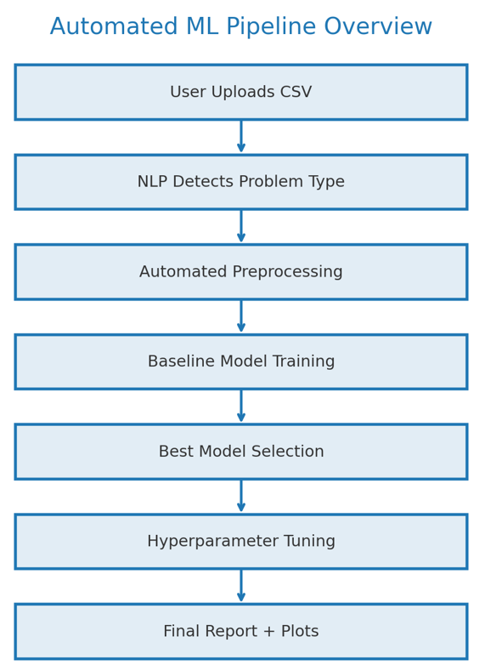

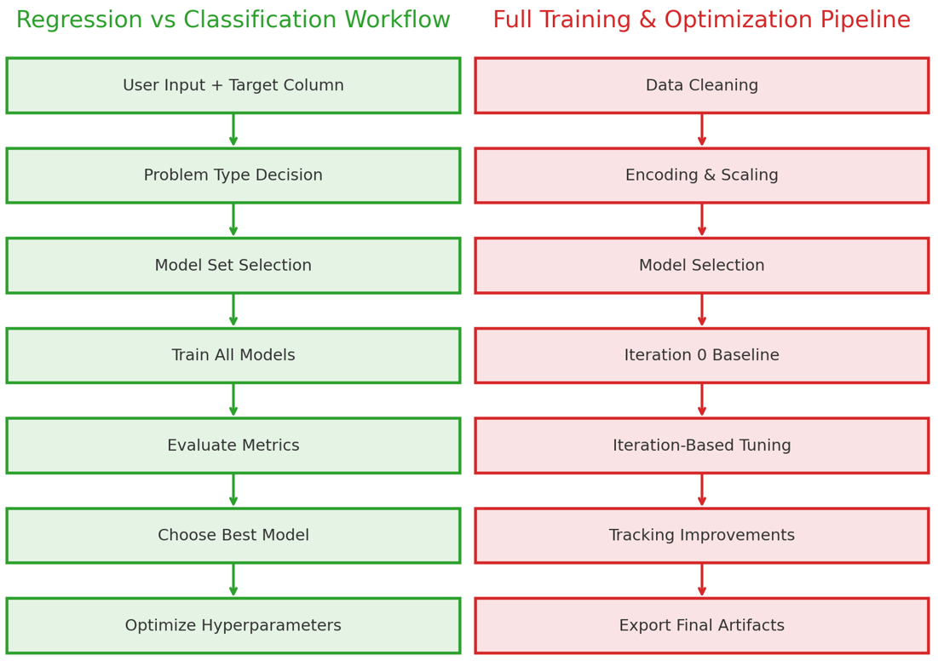

Overview of Project
The AutoML application is structured into four primary backend modules, each interfacing seamlessly with a Tkinter-based GUI:
1. Backend Core
Coordinates data storage, pipeline selection, NLP-driven task detection, execution of ML workflows, and report generation.
2. Regression & Classification Pipelines
Each pipeline implements:
- Data preprocessing
- Feature selection
- Baseline model comparison
- Hyperparameter optimization
- Final performance summary
Regression models: Linear Regression, RandomForest Regressor, XGBoost Regressor
Classification models: KNN, RandomForest Classifier, Neural Network
3. Plotting Module
Generates essential ML visualizations including:
- Target distributions
- Correlation heatmaps
- Feature importance rankings
- Regression scatter plots & residual plots
- Confusion matrices for classification

4. Report Generator
Automatically compiles:
- Baseline performance tables
- Optimized model results
- Hyperparameters used
- Visual plots
- Narrative explanations
- A downloadable ZIP file containing all analysis.

Tools and Technologies
Programming Language: Python 3.x
Libraries: scikit-learn, pandas, numpy, matplotlib, seaborn, spaCy (for NLP), Optuna (for hyperparameter tuning)
GUI Framework: Tkinter
IDE: Visual Studio Code
Version Control: GitHub
UML Design: draw.io / Lucidchart
Document Preparation: Microsoft Word

Project Features

Functional Requirements
- Interactive CSV upload and validation
- NLP-driven detection of problem type
- Automatic or manual target column selection
- Pipeline execution for classification and regression
- Baseline vs. optimized model comparison
- Real-time logs within the GUI
- Visualization of model outputs
- Exportable full analysis report (TXT + HTML + ZIP)

Non-Functional Requirements
- High usability through a clean GUI
- Modular backend ensuring easy maintenance
- Speed-efficient model selection and optimization
- Strong error handling and fallback mechanisms
- Clear, well-structured documentation

Implemented Concepts

1. Natural Language Processing
spaCy is used to:
- Clean and tokenize user descriptions
- Detect keywords associated with classification/regression
- Score similarity for auto-detecting target column

2. Dynamic Machine Learning Pipelines
Each pipeline performs:
- Missing-value imputation
- Automatic encoding
- Feature scaling
- Model comparison
- Controlled hyperparameter tuning
- Final inference and reporting

3. Hyperparameter Optimization
Balanced search strategies ensure:
- Increased accuracy
- Reduced computational overhead
- Avoidance of extreme tuning that makes AutoML slow

4. GUI Development
Tkinter interface supports:
- File uploads
- Live execution logs
- Automatic plot rendering
- Easy access to generated reports

Code
Folder Structure:
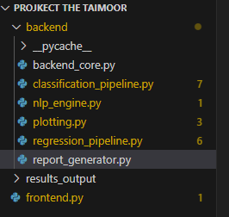
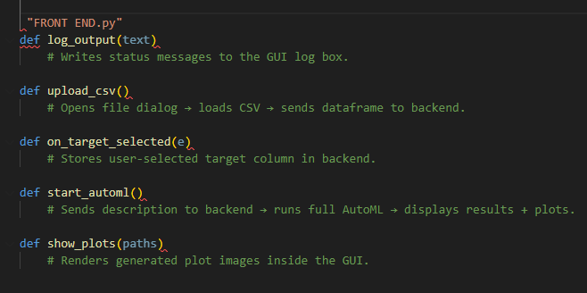
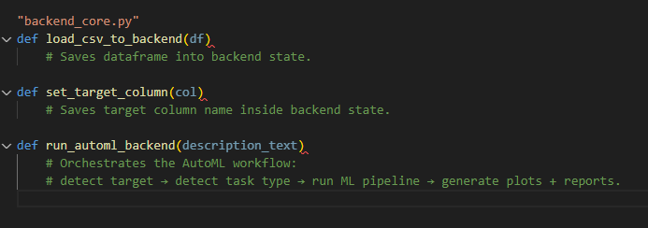
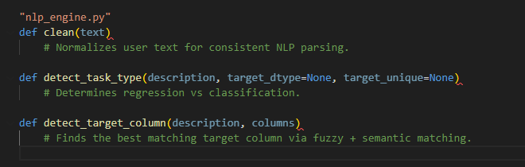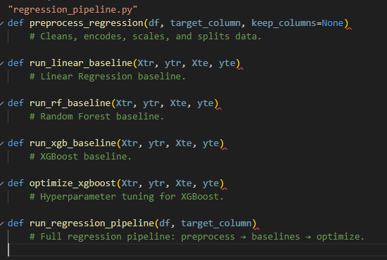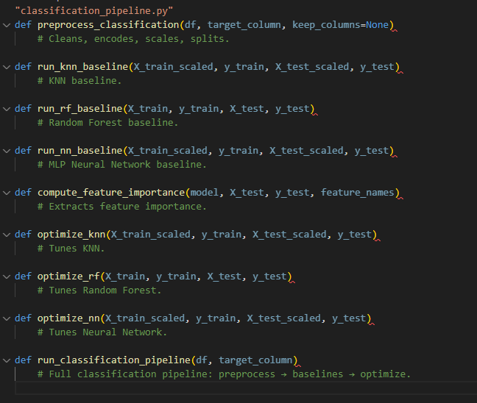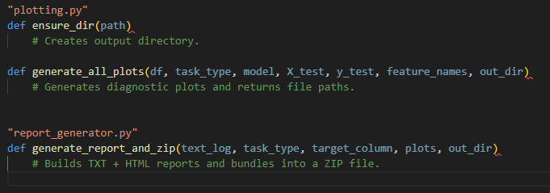

Outputs
Csv1: California Housing –20641 ROWS
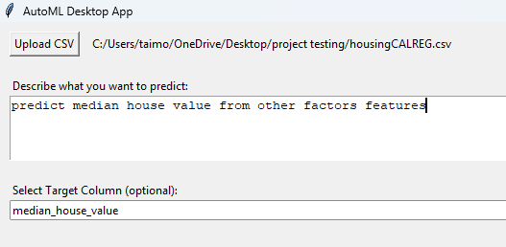
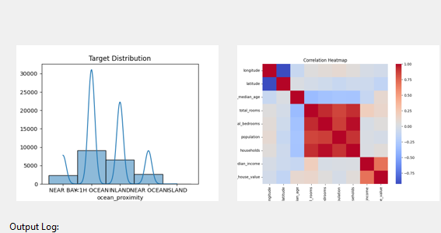
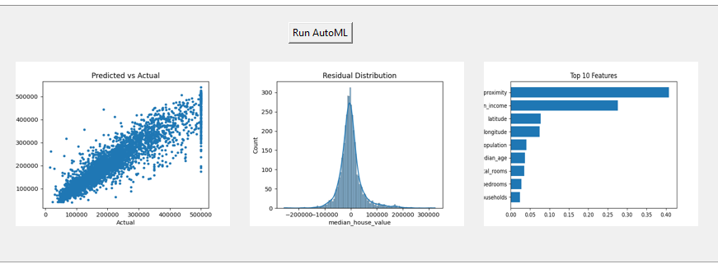
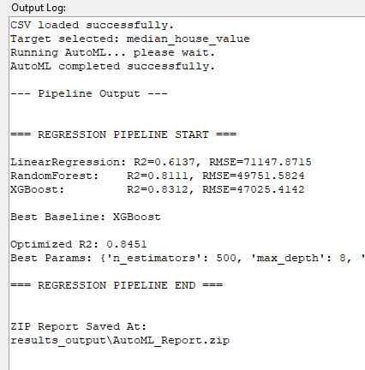

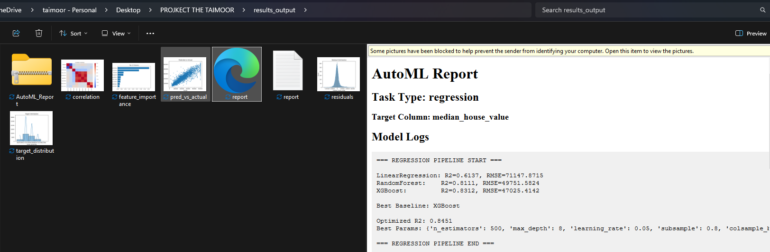

CSV:2 Bank_Marketing – 41k rows – RUNTIME = 01:00.32

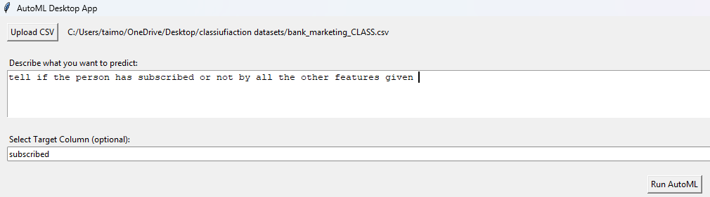
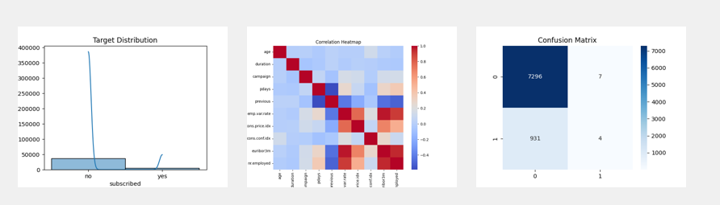
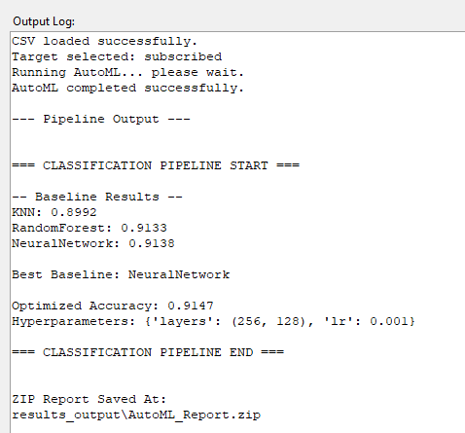
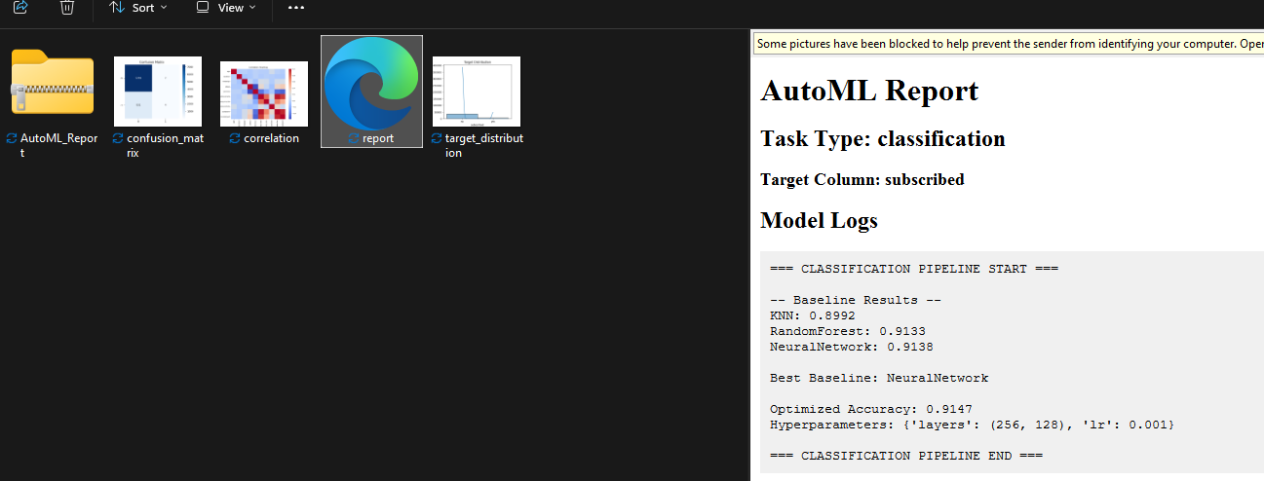

CSV:3 Hotel_Booking Classificaiton
119K ROWS
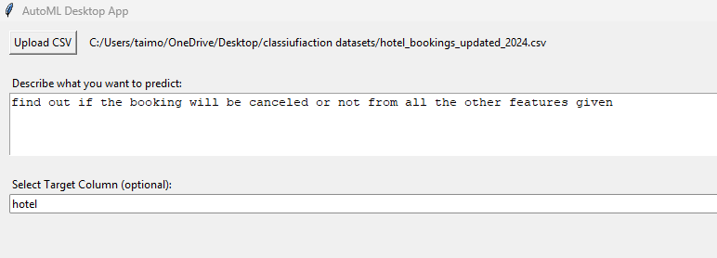

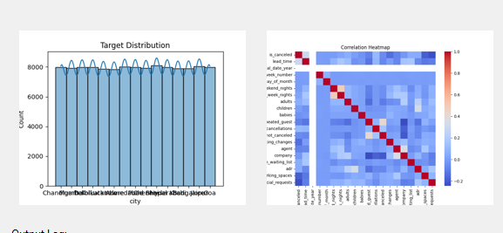

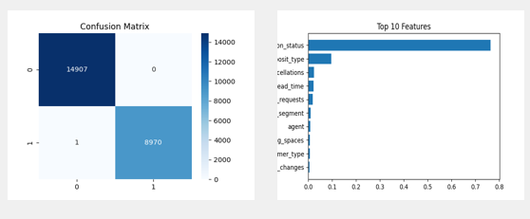
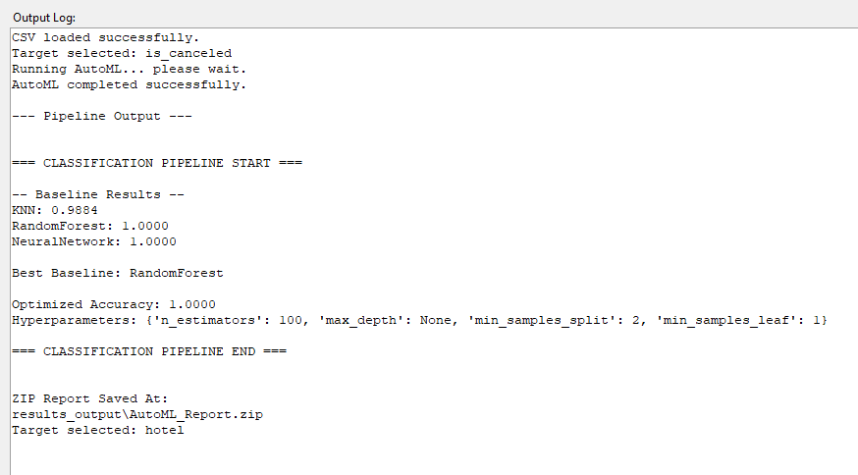
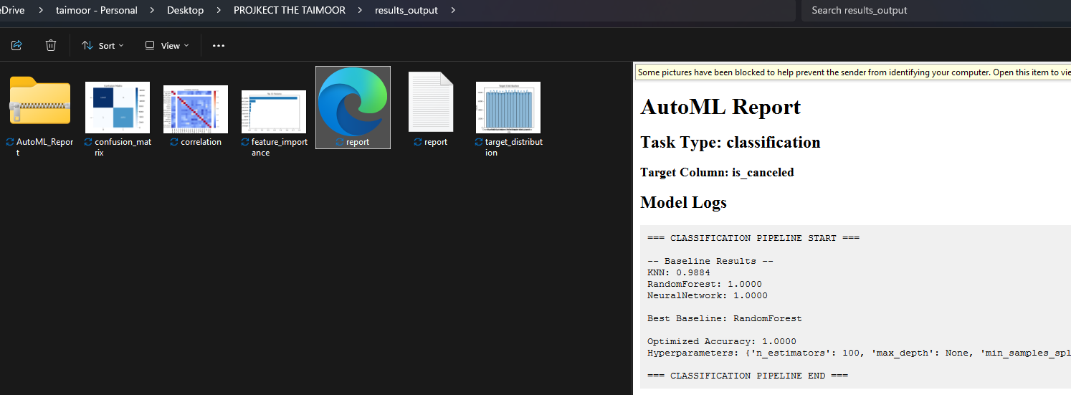
CSV4: Loan_approval_data
50k ROWS
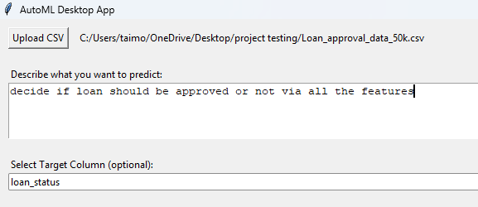
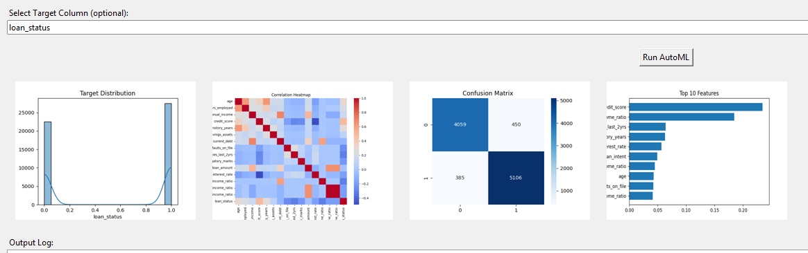
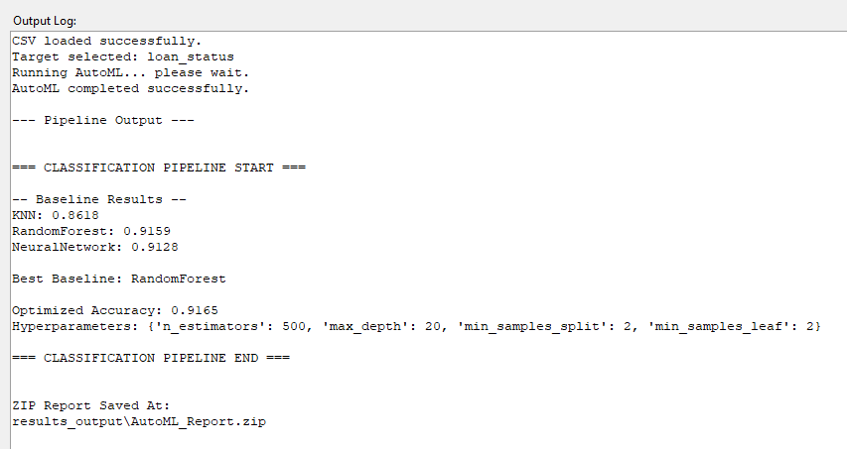
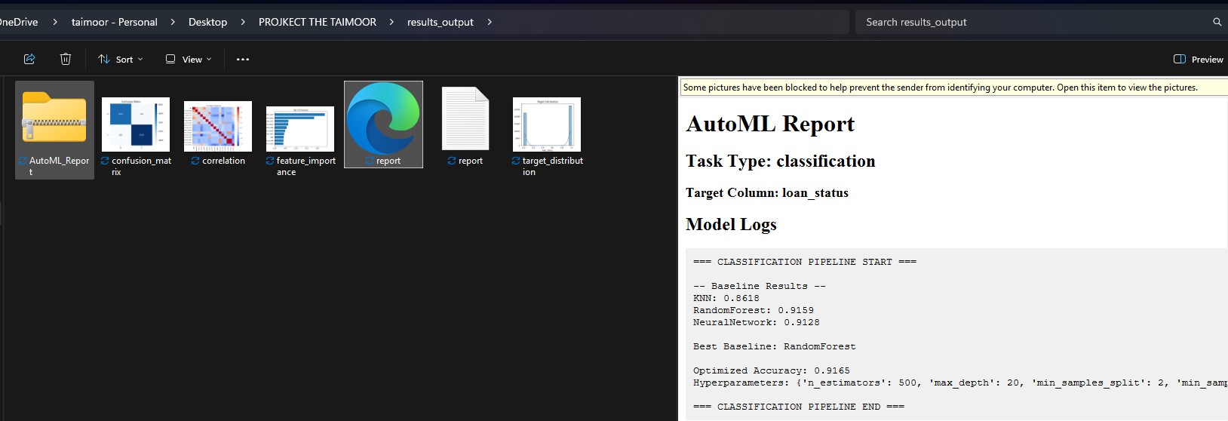

CSV5 ,LABELED(1-4) numeric REGRESSION
10kROWS

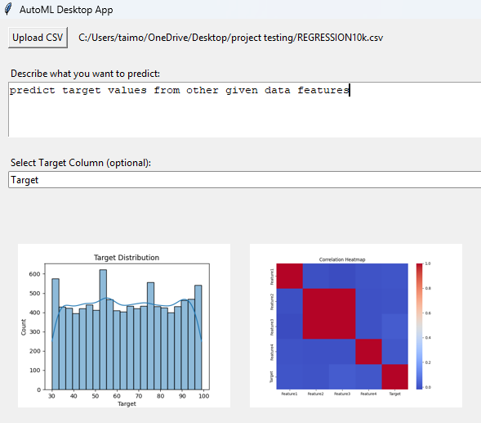
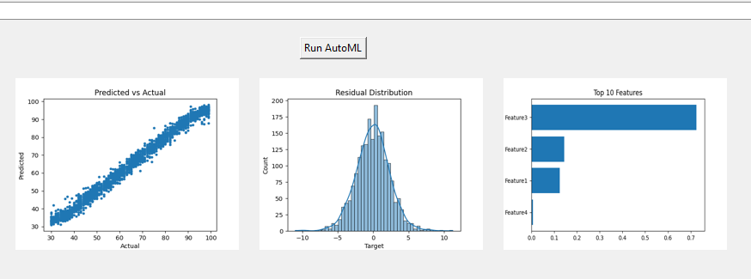
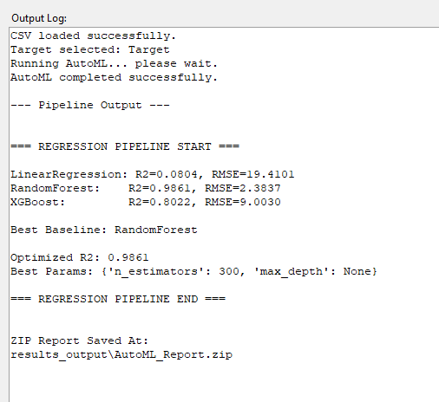

CSV:6 MY_ANIME_LIST RATINGS
20k ROWS
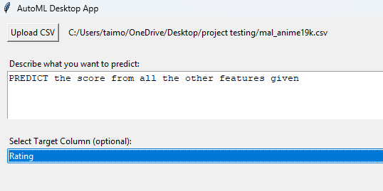
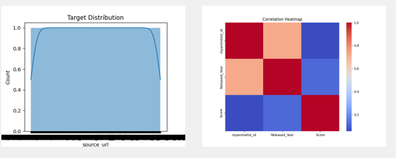
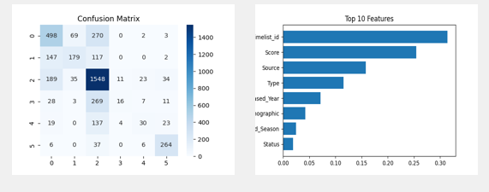
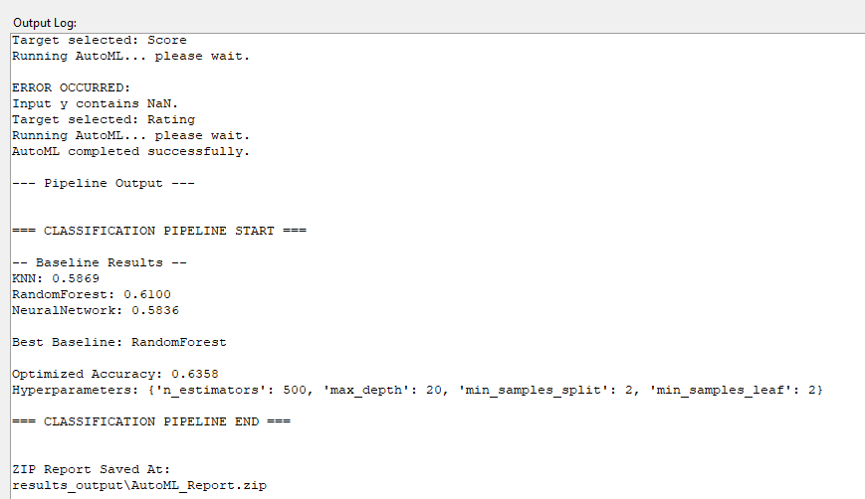
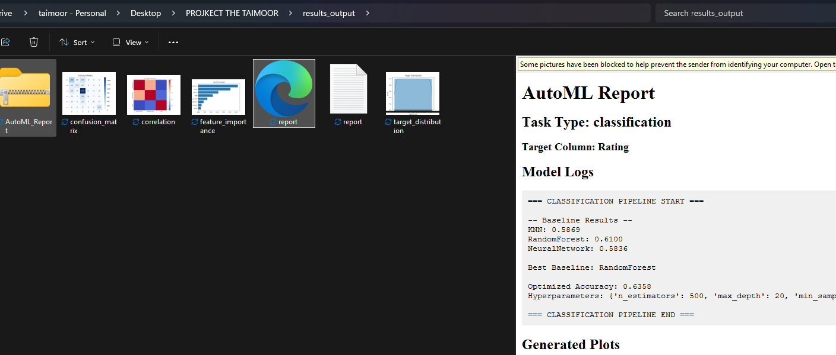

References
- Machine learning models and preprocessing implemented using scikit-learn and XGBoost libraries.
- Public Datasets sourced from Kaggle and Github for testing and validation
- NLP-based problem detection powered by spaCy for text processing and similarity scoring.
- Visualizations generated using Matplotlib and Seaborn.
- GUI built with Python’s Tkinter framework for desktop-based interaction.
- Project version control and development supported through GitHub and Visual Studio Code.
- System design concepts inspired by existing AutoML frameworks such as Auto-Sklearn, TPOT, and Google AutoML.

